**Experiment No.: 3**

**Aim**

Familiarisation of Linux Commands

**CO2**

Perform System administration tasks

**Procedure**

1. **pwd-The path of the current working diectory**



1. **ls- To view the contents of the directory**



* 1. **ls –R – view list of all files in subdirectory**

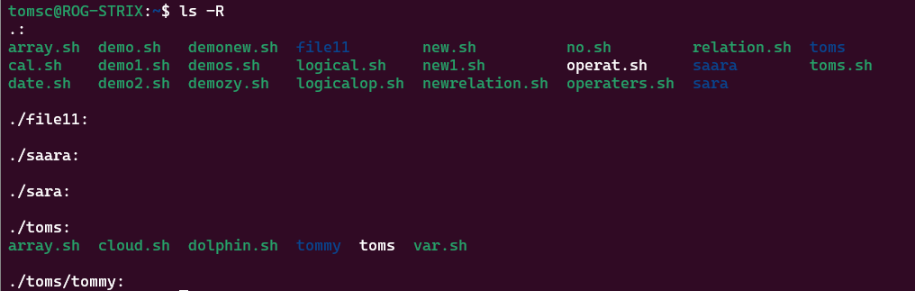

* 1. **ls –l – Long listig of the contents**

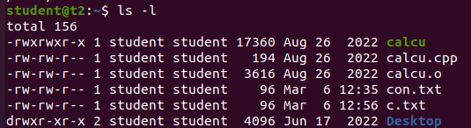

**c)ls –a – to list all the hidden files**

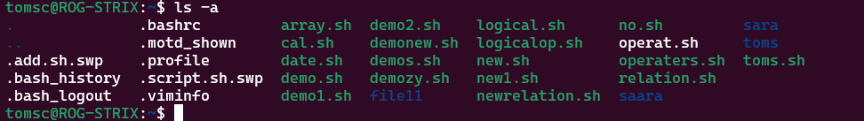

* 1. **ls –al - List the files and directories with detailed information such as owner, file size, permission etc.**

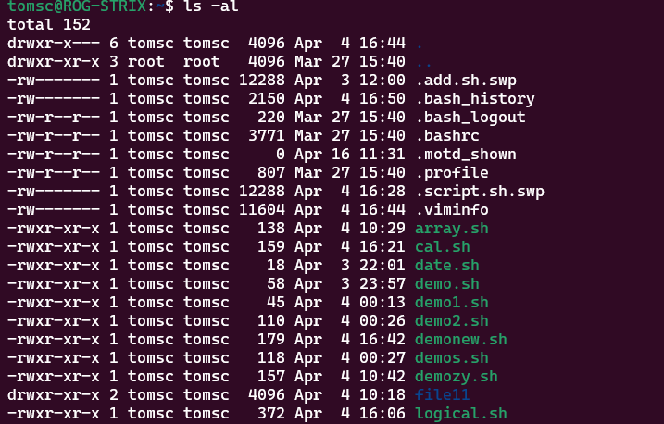

* 1. **ls –t – List the files in the order of last modified**



* 1. **ls –r – To reverse in natural sorting order**

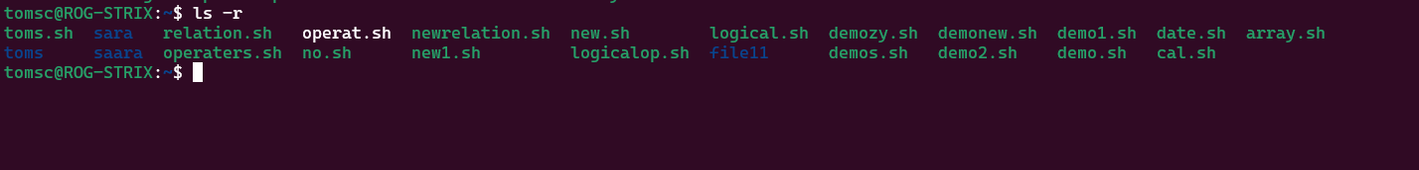

1. **history – To review the commands that have been previously executed for certain period of time**

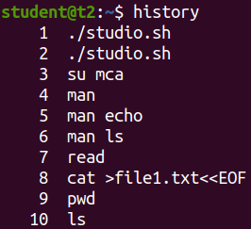

1. **man – You can learn and understand about different commands, write from the shell using man command**

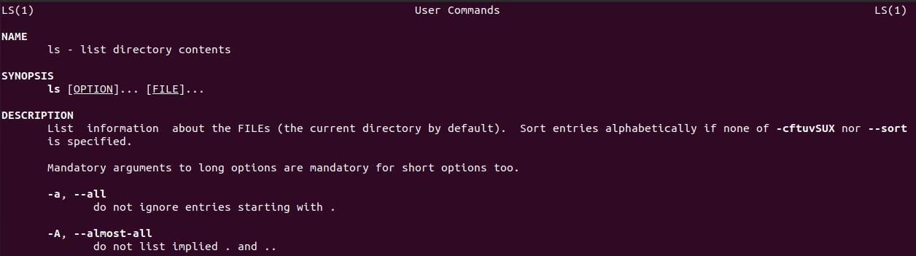

1. **mkdir – To create a new directory**

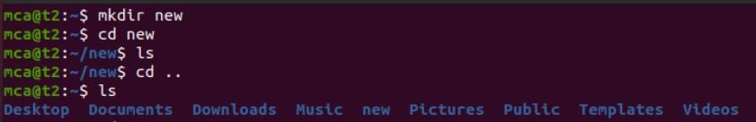

1. **cd –Used to change the directory to previous directory**



1. **rmdir - To remove the empty direcory**



1. **touch – To create a new empty file**

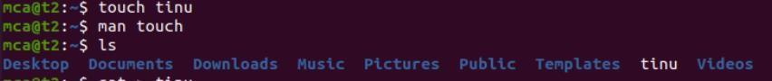

1. **cat – To view, create, concatenate files**
   1. **cat > file1.txt – To add contents**

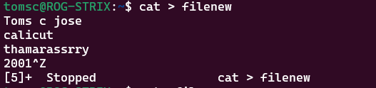

* 1. **cat file1.txt – To view**

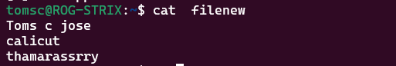

**Ss**

**c)cat >> file1.txt – To append the contents**

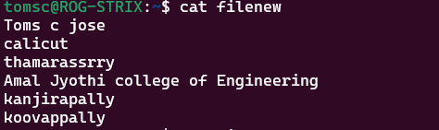

* 1. **cat file1.txt file2.txt > file3.txt – To store the contents of the two files to another file**

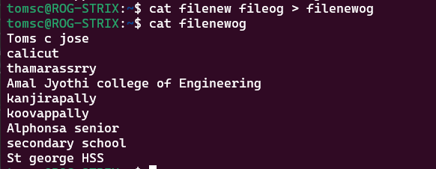

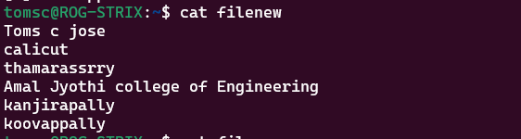

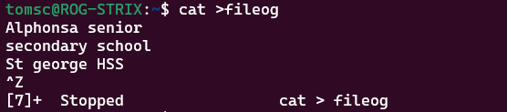

* 1. **cat -n file3.txt – To display the contents with line numbers**

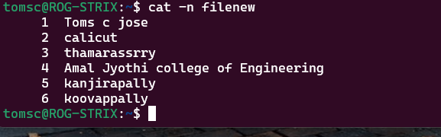

**f ) cat -b file4.txt – To remove the empty line numbers**

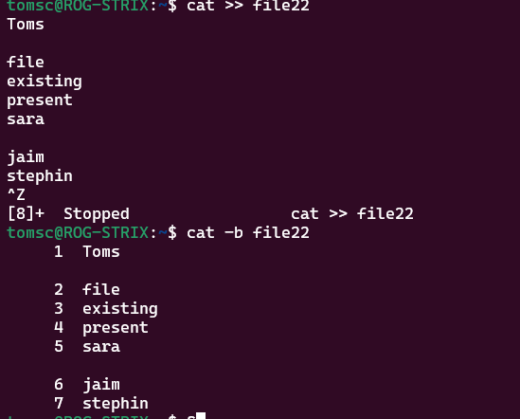

* 1. **cat file1.txt | tr a-z A-Z > output.txt – To change the contents to capital letters**

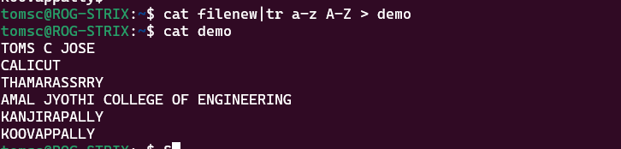

**F)Cat -e -print dollar symbol at the end of each line**



**Result**

The program was executed and the result was successfully obtained. Thus CO2 was obtained.

**Experiment No.: 4**

**Aim**

Familiarisation of Linux Commands

**CO2**

Perform System Aministration tasks

**Procedure**

1. cut-cut the content in a file and output he content in a specified format
   1. **$cut -b1 filename-cut by byte position**

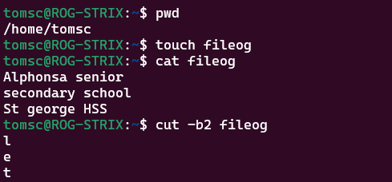

* 1. **$cut -c3 filename-cut by character position**

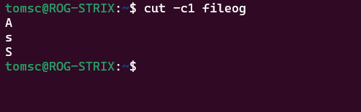

* 1. **cut -d - -f1 filename:** cut command to just print the first field of the file using the delimiter “-”

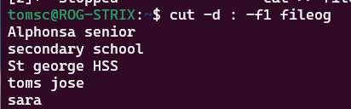

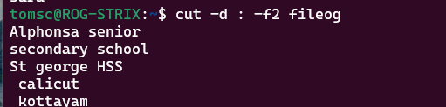

* 1. **cut –c 1,4,6 filename – cut command to cut and print the specified character position**

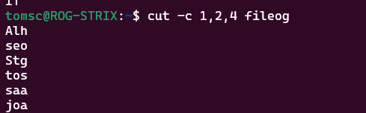

* 1. **cut –d ‘ ‘ –f filename -** cut command to just print the first field of the file using the empty delimiter “”

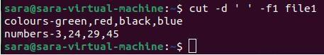

1. **paste- Paste command is used to join files horizontally(Each file consisting of different lines) a)paste file1 file2-To paste file1 contents in file2**

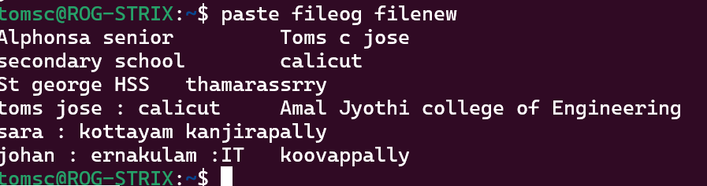

1. **paste file1 file2 > file3-To paste file1 and file2 contents in a new file**

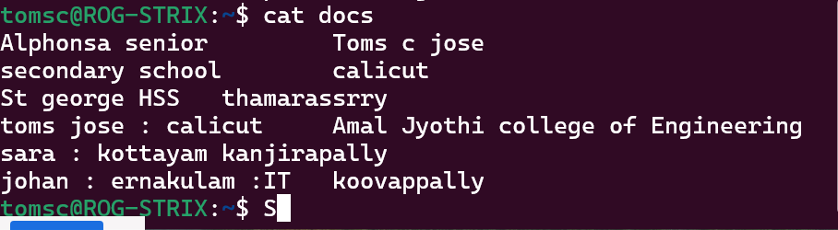

1. **paste –d ‘%’ file1 file2-** By specifying the delimiter, we can also split the lines into columns with specified delimiter.

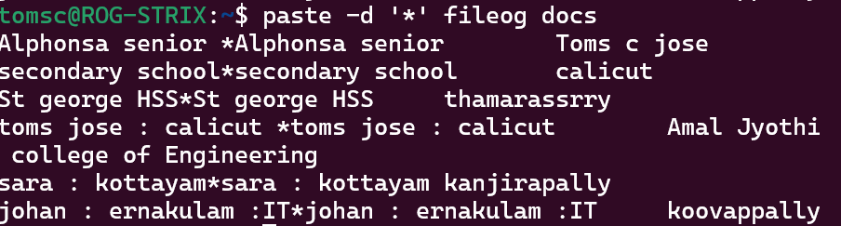

1. **paste –s file1-** Helps to display the contents in the file in a horizontal format



1. **cp - To copy the content to a newfile**
2. **cp file1 file2-To copy file1 contents in file2cat**

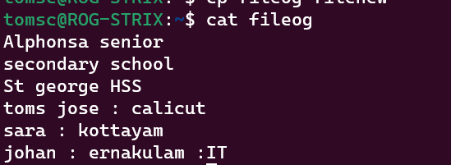

**Result**

The program was executed and the result was successfully obtained. Thus CO2 was obtained.